LAB SHEET


K.R. MANGALAM UNIVERSITY
SOET
(School of Engineering & Technology)
B. TECH CSE (CORE)
Database & Management System Lab (ENCS254)

Submitted by- Submitted to-
Dolly Mansi Kajal
Roll no - 2401010196

LAB SHEET - 1
Objective: To design ER diagrams and convert entities and relationships into relational tables using proper schema notation.

• DDL Commands
1. Create Database
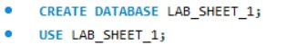

• PART A – COLLEGE DATABASE
- Create Tables with Primary and Foreign Keys
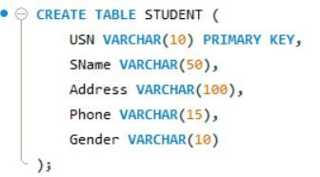
- Create SEMSEC Table
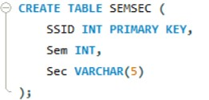
- Create CLASS Table
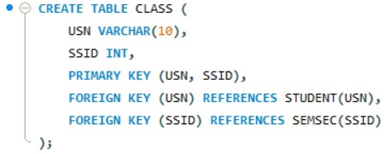

- Create SUBJECT Table
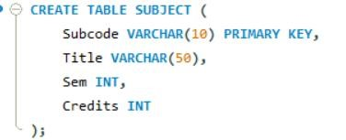
- Create IAMARKS Table
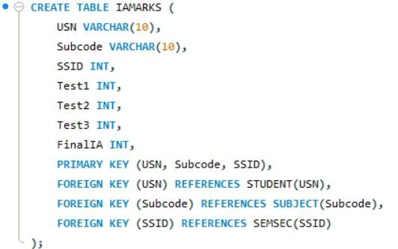

PART B – COMPANY DATABASE
- Create DEPARTMENT Table
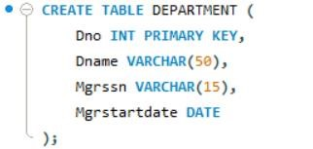
- Create EMPLOYEE Table
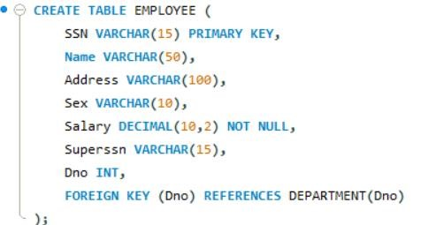
- Create DLocation Table
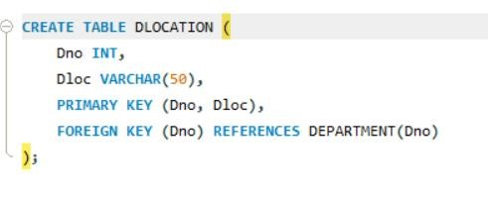
- Create PROJECT Table
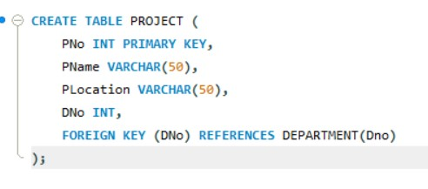
- Create WORKS_ON Table
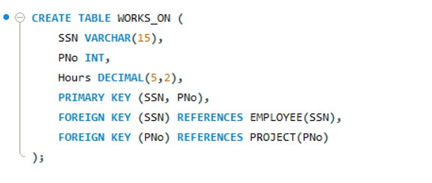

• PART C – CUSTOMER SALE DATABASE
- Create CUSTOMER Table
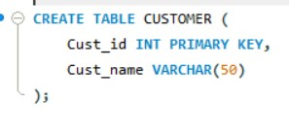

- Create ITEM Table
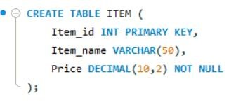
- Create SALE Table
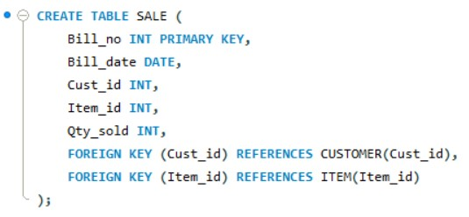

• ALTER OPERATIONS
- Add Email Column
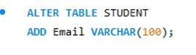
- Rename SName to StudentName
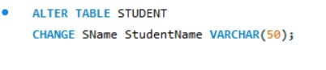
- Drop DLOCATION Table


• DML Commands
- Inserted 10 records into CUSTOMER, ITEM and SALE tables.
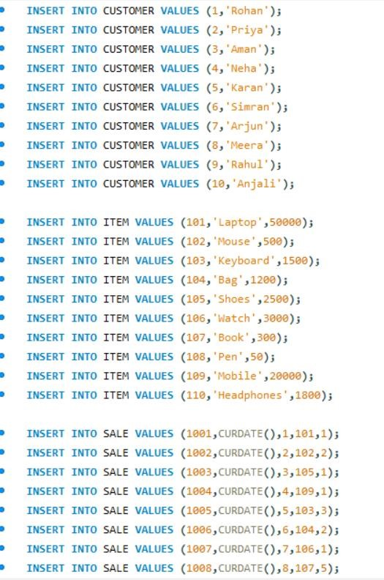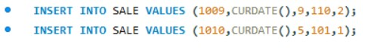

- Bills of Current Date:
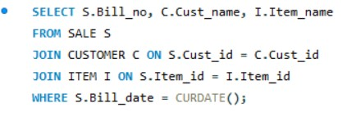

Output:
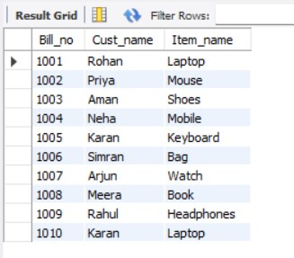
- Total Bill Amount:
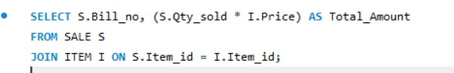
Output:
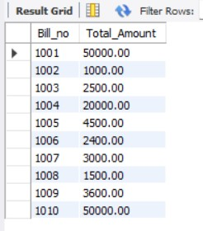

- Customers who purchased products priced above 200.
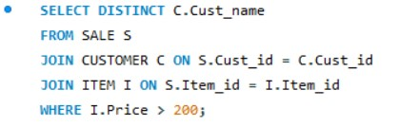
Output:
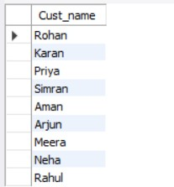
- Count number of products purchased by each customer.
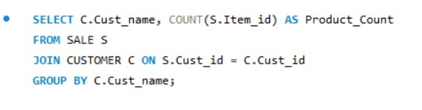
Output:
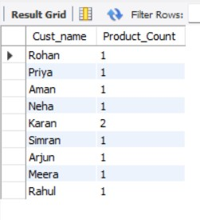

- Products purchased by customer with Cust_id = 5.
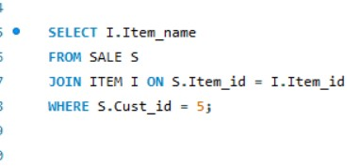
Output:
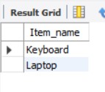

• Views Created
- Bill_Details View (shows bill_no, bill_date, cust_id, item_id, price, qty_sold, amount).
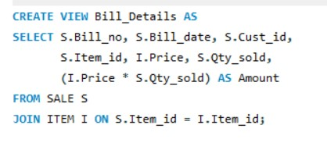

Output:
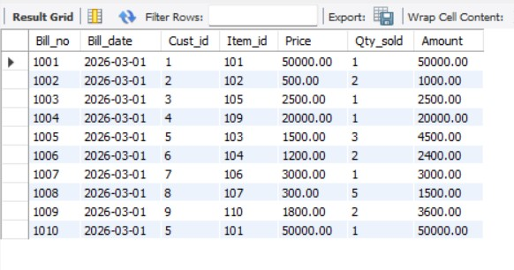
- Weekly_Sales View (shows daily total sales for last one week).
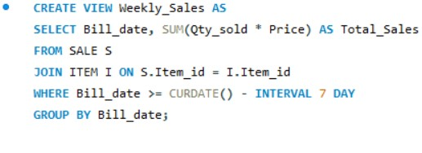

Output:
